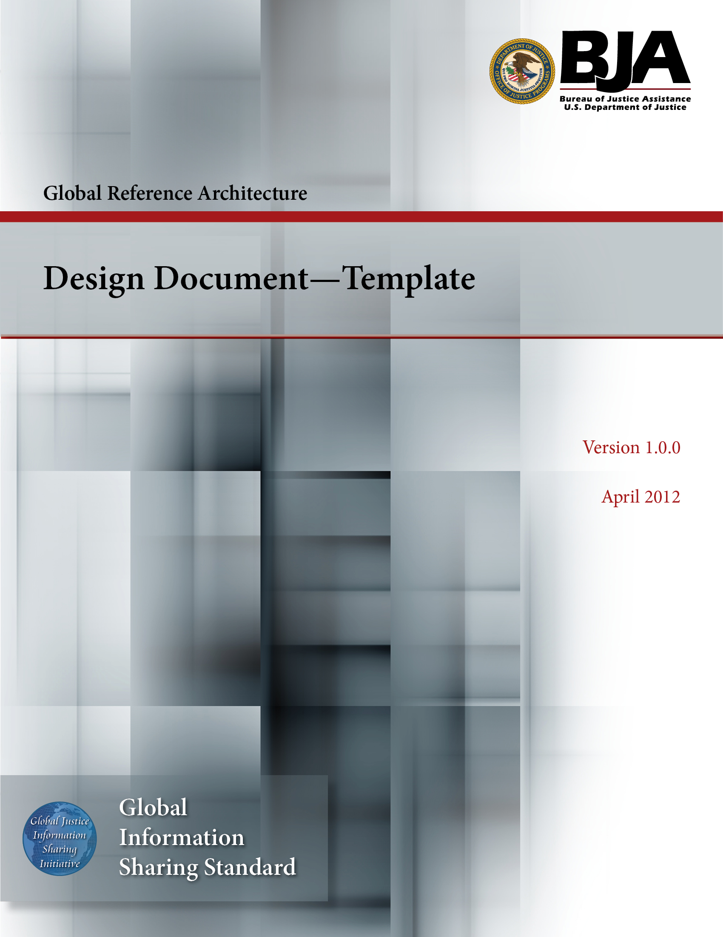



The Global Reference Architecture (GRA)

[Service Name] [Service Abbreviation] [Service Version]

Design Document (Template)

Version 1.0.0

By [Name of Organization]

[Month Year]

Table of Contents

Document Conventions ii
1. Introduction 1
1.1 Purpose 1
1.2 Scope 1
1.3 Definitions, Acronyms, and Abbreviations 1
1.4 References 1
1.5 Overview 1
2. Class Design Model 1
3. Database Design Model 2
4. User Interface Design Model 2
5. Additional Diagrams 2
Appendix A—References 3
Appendix B—Glossary 4
Appendix C—Document History 5

Document Conventions

[Note: The following template is provided for use with the Service Development Process. Text enclosed in square brackets and/or displayed in blue is included to provide guidance to the author and should be deleted before publishing the document.]

<Project Name> Design Document

Introduction

[The introduction of the Design Document provides an overview of the entire Design Document. It includes the purpose, scope, definitions, acronyms, abbreviations, references, and overview of the Design Document. The purpose of this document is to simply put it all together to show a reader all the models in one document. This approach may or may not be useful for your project. Do what suits bests and adds value.]

Purpose

[This section defines the role or purpose of the Design Document in the overall project documentation and briefly describes the structure of the document. The specific audiences for the document are identified, with an indication of how they are expected to use the document. The Design Document is the aggregation of all the design models along with any other diagrams such as sequence, collaboration, etc.]

Scope

[A brief description of what the Design Document applies to; what is affected or influenced by this document.]

Definitions, Acronyms, and Abbreviations

[This subsection provides the definitions of all terms, acronyms, and abbreviations required to properly interpret the Design Document. This information may be provided by reference to the project’s Glossary.]

References

[This subsection provides a complete list of all documents referenced elsewhere in the Design Document. Identify each document by title, report number (if applicable), date, and publishing organization. Specify the sources from which the references can be obtained. This information may be provided by reference to an appendix or to another document.]

Overview

[This subsection describes what the rest of the Design Document contains and explains how the Design Document is organized.]

Class Design Model

[Here, include the Class Design Model. Sometimes, it might seem reasonable to have separate storage locations for the various models, and that is acceptable.]

Database Design Model

[In this section, include the database design model.]

User Interface Design Model

[In this section, include the User Interface (DI) Design Model. This includes both UI prototype(s) and navigation map(s).]

Additional Diagrams

[In this section, include any other diagrams that have not found place in any of the documents and still seem important to be part of the Design Document. It is important to realize the value of your models and what part of the process they belong to. Good examples of additional diagrams are sequence diagrams, component diagrams, collaboration diagrams, etc. You can decide to group these diagrams as different sections or have them under this common Additional Diagrams section.]

Appendix A—References

[This section is used to list applicable references.]

[Reference name and description] | [Fully qualified link/path to the reference information]

Appendix B—Glossary

[This section is used to list glossary terms used in the document.]

[Glossary term or acronym] | [Glossary term or acronym description]

Appendix C—Document History

[This section is used to document the history of the service description document.]

Date | Version | Editor | Change
December 11, 2011 | 1.0.0 | James Dyche  Iveta Topalova | Final 1.0.0 revision
December 20, 2011 | 1.0.0 | David Gillespie | Initial edit of 1.0.0 revision
April 2012 | 1.0.0 | Global Standards Council (GSC) | Global Advisory Committee (GAC) approved



